ACTGov_EaT_inline_293

# Giralang Preschool Unit

**Management of Play Dough**

REF: Staying Healthy (NHMRC 2012)

Giralang Preschool acknowledges that Play dough can be great fun and develops children’s creativity and fine motor muscles.

**The following simple steps will reduce the risk of spreading infections when using play dough:**

1. Children and adults using play dough should wash their hands with soap and water or use an alcohol based hand rub before and after using play dough
2. The cooked play dough recipe should be used ensuring a high salt content, which discourages germs from living and multiplying
3. Additional textures can be added to the play dough during the cooling stage (for example glitter, rice, split peas, beads, wishing stones etc) or increase the sensory appeal (add a few drops of lavender oil or warm it up)
4. Make a new batch of play dough each week. Store the play dough in the refrigerator, covered with an expiry date ensuring that pieces with obvious foreign bodies are discarded
5. Take out just enough play dough for each day
6. Have the children wash their hands after the experience

**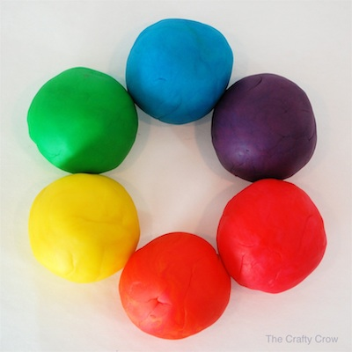Cooked Play Dough Recipe (for 2-3 children)**

1 cup of plain flour

½ cup of salt

1 tablespoon of vegetable oil

1-2 tablespoons of Cream of Tartar (1 tablespoon for firmer and 2 tablespoons for softer styles)

1 cup of water with food colouring added

**Method:**

Place all ingredients in a saucepan and mix over a medium heat for 3 to 5 minutes stirring continuously until it becomes thick and the dough leaves the side of the pan clean. Cool and knead for a few minutes until smooth.