ACTGov_EaT_inline_293

# Giralang Preschool Unit

**Toilet Training Procedure**

*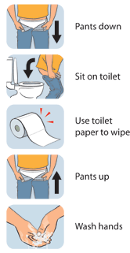For children who are being toilet trained, this procedure is completed within every 90 minutes to 120 minutes (but no longer than 120 minutes) whilst at the preschool.*

**Timed Toileting procedure**

1. Staff are to wash and dry their hands, then put gloves on.
2. Remove child’s nappy/pullups, or encourage child to remove their underpants & clothing, assist if required.
3. Assist child to sit on the toilet
4. Encourage child to clean from front to back with toilet paper, assist if required.
5. Assist the child off the toilet, and encourage child to flush toilet, assist where required
6. Encourage the child to put on their own underpants and clothing, assist if required, or replace child’s nappy (following the nappy change procedure)
7. Peel gloves off, turning them inside out and place in the bin.
8. Assist the child to wash and dry their hands and return them to the play area
9. Record on the Nappy/Toileting Communication Record in the child’s bag if required or arranged with family

**Dealing with Soiled Clothing**

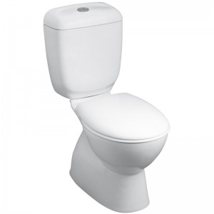At all times, staff are to assist a child who has been incontinent. It is not appropriate to notify and wait for a family to arrive unless this arrangement has been made as an individual agreement in advance and there is an agreement that a family member will always be available to support the arrangement.

1. Staff are to use gloves to place any soiled clothing into a plastic bag
2. The plastic bag is then placed inside another plastic bag. If the bag contains urine or faeces a pre-prepared yellow alert tag (laminated paper hole punched with an elastic band insert) is placed around the knot of the plastic bag as a visual cue for families
3. Gloves are Peeled off, turned inside out and placed in the bin.
4. Staff to wash and dry their hands.

**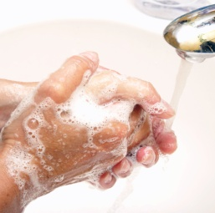Children who are toilet learning must not be left alone to self toilet.**

*Toilet Learning should be a positive experience for children. During toileting carers and children have an opportunity to interact one on one, build trusting and caring relationships and extend on a child’s self help skills.*