

**11 February 2015**

**CALENDAR OF EVENTS**

11 Feb Parent Information Evening 5.00pm & AGM 7.30pm

13 Feb Assembly 2.00pm, presented by Yr 6

17 Feb Year 2, Giralang Wetlands

27 Feb Assembly 2.00pm, presented by Year 3

13 March Assembly 2.00pm, presented by Year 1

27 March Assembly 2.00pm, presented by Year 2

9 April Assembly 2.00pm, presented by Year 4

**FROM THE** **PRINCIPAL**

**A WARM WELCOME**

Our students and staff have enjoyed a wonderful start to 2015! I am so impressed with the settled nature with which the students have returned and have approached their new classes and learning environments. I would like to extend a warm welcome to all of the new families who have joined us at Giralang PS in 2015. Our current enrolment is 291 students from Preschool to Year 6. This is an exciting time as we watch our school grow and expand to share the adventures in learning, caring and achieving.

**DAILY BREAK TIMES**

Please note the following daily timetable for 2015:

9.00 - 11.00am Teaching and learning session 1

11.00 – 11.30am Recess break

11.30 - 1.00pm Teaching and learning session 2

1.00 - 1.10pm Supervised lunch eating time

1.10 – 2.00pm Lunch break

2.00 - 3.00pm Teaching and learning session 3



**CLASS ARRANGEMENTS FOR 2015**

This year we have 3 preschool groups and 11 primary classes. We have straight classes from P-4 with one Year 4/5 class, one Year 5 class and one Year 6 Leadership class. Classes will, from time to time, get together with multi-age groups for enrichment activities throughout the year.

**KEEPING YOU INFORMED**

As I mentioned in my welcome letter last week you are invited to come along to our ‘Meet the Teacher’ evening TONIGHT commencing at 5.00pm. The timetable is as follows:

5.00pm – Preschool

5.20pm – Kindergarten

5.40pm – Year 1

6.00pm – Year 2

6.20pm – Year 3

6.40pm – Year 4

6.55pm – Year 4/5 and Year5

7.00pm – Year 6 Leadership Class

The P&C AGM will follow in our Library at 7.30pm.

A ‘Welcome Barbeque’ will commence at 5.00pm on the lawns at the front of the school. Please drop past for something yummy to eat and to make new connections with other Giralang Primary and Preschool families. The BBQ is free of charge and we will also be offering cups of water and cordial.

**SCHOOL ASSEMBLY**

At Giralang Primary assemblies are held every second Friday at 2.00pm in the school hall. Parents and carers are very welcome to attend. This Friday will be a very special assembly hosted by our Year 6 Leadership class.

**TWO NEW FACES**

As well as welcoming new students to our school we are also welcoming two new staff members. Rebecca (Beck) Verdon will be teaching Preschool this year. Our former Preschool teacher Katrina Maciver has accepted a 12 month teaching position with the Taqwa Islamic School in the ACT. Also joining us this year is our new School Psychologist Courtney Bruce. We hope their time with us is both enjoyable and fulfilling.

**BEFORE AND AFTER SCHOOL SUPERVISION**

Parents are reminded that there is no direct supervision of children in the playground before 9.00am. The library opens each morning at 8.30am for students. It is desirable that students are dropped off at school as close as possible to 9.00am. If students require assistance before school they should go to the Front Office or seek the help of an Executive Teacher. School concludes at 3.00pm. Children should go directly home unless they are attending After School Care. Please ensure your children know the correct procedures for going home each day.

Belinda Love - Principal

**INTRODUCING…**

**COURTNEY BRUCE**

Hello to all, I hope you are enjoying 2015 so far! My name is Courtney Bruce and I am very excited to join the Giralang Primary School community as the new School Psychologist. I have a great passion and enthusiasm for working with children, their families and teachers to help our young stars achieve to the very best of their ability. I look forward to getting to know you all over the coming year and working together. I will be located in the school every Wednesday and on Tuesdays every odd week.

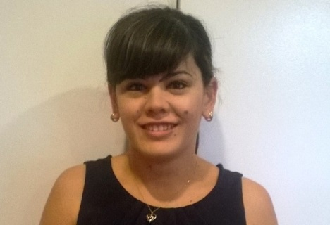

[](http://www.google.com.au/url?q=http://www.clker.com/clipart-135350.html&sa=U&ei=I1HZVL2FMOPZmgXF34GwAw&ved=0CBwQ9QEwAw&usg=AFQjCNFAaQ6gNXANMwaRwYwk6kFuTuox6w)**FROM THE P&C**

I would like to this opportunity to encourage our parents to consider taking on a role in the P and C this year. It's a great way to get involved, make friends, and learn new skills. You can do as little or as much as you wish, from baking a cake for an event to taking on one of the official roles - secretary, president, etc. Even if you haven't been president or secretary before, but would like to have a go, consider doing so as there's plenty of support and the experience of others to tap into.

At Wednesday night's AGM, we will also be calling for interested parents to join a relatively new committee which will look at the security fence, parking issues and the shopping centre redevelopment. If you wish to be on that committee, please come along to the meeting.

The AGM will start after the information sessions at 7.30pm.

If you would like to know more about any of the roles, please get in touch.

Jennifer Sexton

President [giralangpandc@gmail.com](mailto:giralangpandc@gmail.com)

**UNIFORM SHOP**

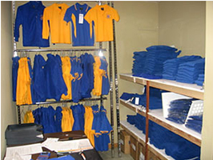

The Uniform Shop is open every Friday from 8.30-9.15am.

[](http://www.bing.com/images/search?q=school+banking+clipart&qpvt=school+banking+clipart&FORM=IGRE&adlt=strict#view=detail&id=ADBCF64C7C75D40715DCCD7332D42F63562C2724&selectedIndex=0)**SCHOOL BANKING**

“Welcome back to another year of school banking. This year has a space theme with some great reward items and prizes. Your child will receive an information pack with their first school banking deposit”.

Cate Ticehurst

School Banking

**PRESCHOOL FEEDBACK**

What a wonderful start to the preschool year! I hope your children have enjoyed the many and varied challenges over the past week as they embark on their journey with education.

As your child’s first teacher, we acknowledge and value your input into the preschool program. We want your child’s learning experiences to be relevant and engaging and to ensure we do this, we are asking for your feedback to help guide the program and provide feedback to help us improve our professional practice – teaching your children!

In the family room, you will find the preschool program for each group and space for you to add any thoughts or comments. Thank you to those families who have already taken the time to make a written contribution to the program. It is much appreciated.

Throughout the year we will put a spot light on other areas of the preschool for your feedback.

Lili Jankovic - Executive Teacher

**PRESCHOOL - FIREWORKS**

The Preschool Fireworks have had lots of fun over the last few days! The Red Sparklers (M-W Jess), the Yellow Pinwheels (M-W Beck) and the Orange Firecrackers (W-F Beck) have been getting to know the teachers, the other students, and using lots of equipment and exploring all of the spaces here at Preschool. We have created paintings, ridden bikes, played in the sand, read books, made music and swung high up into the sky. We have chatted, laughed, cried, smiled, sung and rested our voices. We can’t wait to see what adventures the next few weeks bring! Could you please bring in a family photo to share for our next focus program if you haven’t already done so?

Beck Verdon – Preschool Teacher

Jess Morris – Preschool Teacher

[rebecca.verdon@ed.act.edu.au](mailto:rebecca.verdon@ed.act.edu.au)

[jessika.morris@ed.act.edu.au](mailto:jessika.morris@ed.act.edu.au)

**KINDERGARTEN – STARS & TWILIGHTS**

We’ve had a wonderful time getting to know all the Kindergarten students over the last week. They’ve been very busy learning all the new routines in their classrooms and doing lots of fun activities. Miss Duncanson taught the students a new song called ‘Slippery Fish’ with some fun hand actions.

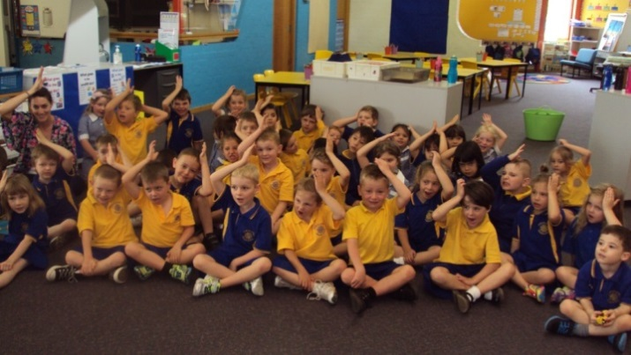

***Stars (KCD) & Twilights (KLN)***

We would like to say a BIG thank you to all the parents who’ve been busy covering books for the Kindergarten students. We really appreciate the time you’ve taken to do this.

Carly Duncanson – Kindergarten Teacher

Leanne Nicol – Kindergarten Teacher

[carly.duncanson@ed.act.edu.au](mailto:carly.duncanson@ed.act.edu.au)

[leanne.nicol@ed.act.edu.au](mailto:leanne.nicol@ed.act.edu.au)

**YEAR 1 – SUPERNOVAS & RAINBOWS**

Our ‘new’ Year one students have settled enthusiastically and quickly into their new classrooms.

1F students have been very busy taking part in activities such as programming a robot and designing their own house that is to go on the special BeeBot robot mat (see the completed mat in the image). Students have also completed a range of problem solving activities including the ‘Great Egg Drop’ (of which images can be seen on our classroom wall).

1K students have been learning about what makes a rainbow and creating our own rainbows using paper, a glass of water and sunlight. We have been working in teams for problem solving activities and have already learnt lots of new songs and dances. Our classroom has been decorated with every colour of the rainbow!

Thanks to those parents and guardians who have already returned contacted books. It will assist us in ensuring your child/rens books look neat throughout the year.

Please contact us if you have any queries or you wish to let us know about upcoming absences.

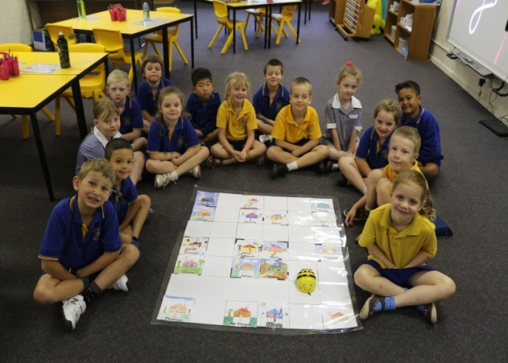

***Supernovas (1PF)***

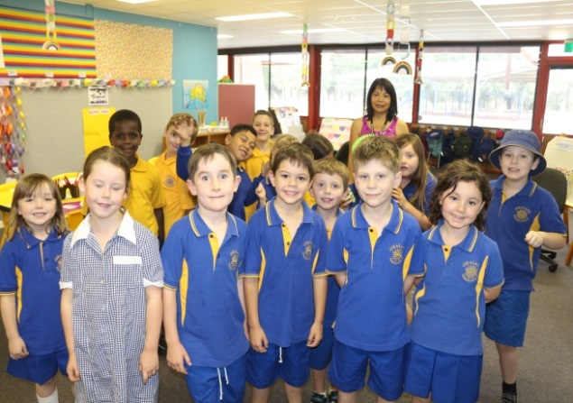

***Rainbows (1SK)***

Skye Knight – Year 1 Teacher

Paul Floyd – Year 1 Teacher

[skye.knight@ed.act.edu.au](mailto:skye.knight@ed.act.edu.au)

[paul.floyd@ed.act.edu.au](mailto:paul.floyd@ed.act.edu.au)



**YEAR 2 – PHOTONS & AURORAS**

Welcome to 2015! What a busy week and a half we have had! The students have enjoyed getting to know each other and their new teachers. We have been completing lots of activities including learning about our class names and 2M have completed some beautiful aurora artworks. You will find these on display in either Miss Love’s office or the Year 2 area. We have also thoroughly enjoyed learning new songs that Mr Bormann has been teaching us and singing along to the guitar.

We have commenced our Water Integrated unit. We have discussed what we already know and what we would like to learn. In week 1 we went on a water walk around the school and discovered many places where water is used. Please come down and look at our photo display in our area.

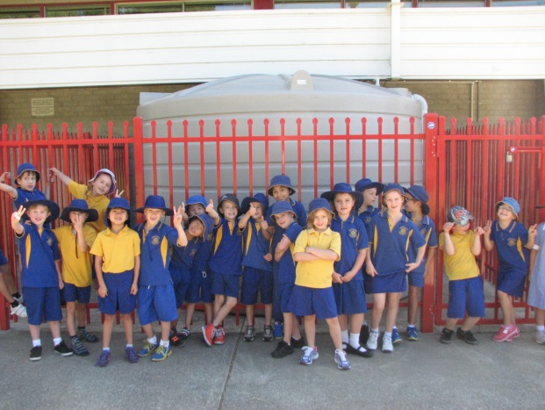

***Auroras (2KM) on their school Water Walk***

Important- A note has been sent home about an excursion to the Giralang Wetlands and storm water drains on Tuesday in week 3. Please ensure this is signed and returned. There is no cost.

We look forward to seeing you all tonight for the community barbeque and Meet the Teacher night!

Mark Bormann – Year 2 Teacher

Karly Malmberg – Year 2 Teacher

[mark.bormann@ed.act.edu.au](mailto:mark.bormann@ed.act.edu.au)

[karly.malmberg@ed.act.edu.au](mailto:karly.malmberg@ed.act.edu.au)

**YEAR 3 – SUNRISES**

[](http://www.google.com/url?q=http://cliparts.co/good-job-clip-art&sa=U&ei=Ek3ZVLGlLs2m8AWZ_IKQBA&ved=0CCIQ9QEwBg&usg=AFQjCNEt1JHMBh8fyTqI9Z8302MAyhvAZg)Wow! What a fantastic start to the year! Year 3 has settled in beautifully and we are enjoying all of the new things we are learning every day. This fortnight we have been revising our mental computation strategies in Maths, discovering and brainstorming what makes a great exposition in Literacy and looking at the differences between night and day in Integrated Unit.

We are looking forward to a fun filled Term 1 and a terrific 2015. If you have any queries or concerns, please feel free to contact us.

We hope you can join us for our Parent Information Session on Wednesday beginning at 5.00pm.

Beth Lessard [bethany.lessard@ed.act.edu.au](mailto:bethany.lessard@ed.act.edu.au)

Dot Hepburn [dorothy.hepburn@ed.act.edu.au](mailto:dorothy.hepburn@ed.act.edu.au)

[](http://www.relayforlife.org.au/)

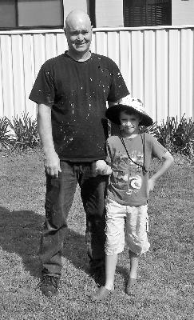

“Hi my name is Blake. I am 8 years old and I am in year 3 at school. I am participating in the relay for life in honour of my Papa who passed away from cancer last year. My goal is to raise $100 and to complete 100 laps. I want to help scientists cure cancer so other people don't pass away because of cancer. Thank you for your donation. From Blake Miller”

To make a donation to support Blake’s fundraising goal please visit his personal link or search Blake Miller, member of Pete’s Peeps. Thank you.

<http://fundraising.cancer.org.au/site/TR/RelayforLife/CCACT?px=1107985&pg=personal&fr_id=1883>

**YEAR 4 – FIREFLIES**

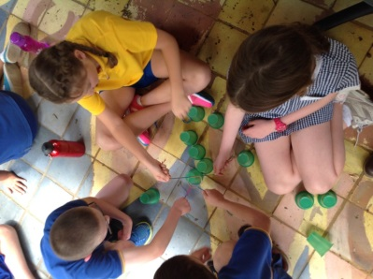The 4G Fireflies had a very busy week 1, with lots of fun activities. A highlight for everybody was a team-building activity where we had to create a structure from spaghetti, tape and blue tack. Each group had a very different approach, and there were several collapses, but eventually all of the groups created an amazing structure.

The Fireflies have library time on Wednesday mornings and will start bringing home readers which need to be returned after being read. I would also love all parents and guardians to attend the Welcome BBQ tomorrow night. It will be a great opportunity for me to get to know all of the families.

If you have any questions or concerns do not hesitate to contact me:

Matt Garratt – Year 4 Teacher

[matthew.garratt@ed.act.edu.au](mailto:matthew.garratt@ed.act.edu.au)

**YEAR 4/5 - SPARKS**

The Sparks have got off to a flying start to the year. In week one, we focused on team building including setting expectations, recognising qualities of teammates and co-operation. Our ‘Recipe for Success’ gave students the opportunity to unpack qualities that they value in order to be successful in the classroom. We shared our success and our hot chocolates with our families. Students also enjoyed a range of games to improve team work, communication and observation. Another key lesson the students participated in was how to choose a book that is just right for them. Decisions were based on purpose, interest, comprehension and knowledge of words (I PICK).

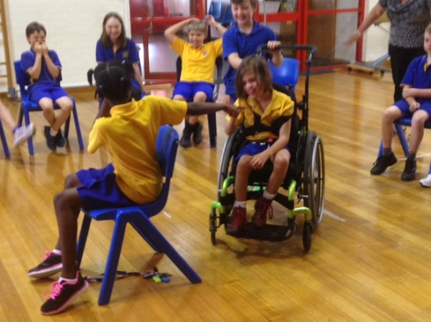

***Muzn, Ayla and Aidan***

I am looking forward to meeting all the families on our meet the teacher evening.

Meredith Wells – Year 4/5 Teacher

[meredith.wells@ed.act.edu.au](mailto:meredith.wells@ed.act.edu.au)

**YEAR 5 – LASERS**

Hello and welcome to another great year at Giralang Primary School.

The students have all settled into class well and are very excited to start some new programs this year. In Year 5 this year we will be working closely with the Year 4/5 Sparks on a range of exciting new learning styles. There will be more information shared about this at the Parent Information session.

Last week we were doing a lot of team building and relationship building activities, along with “getting to know you” activities. This will help set our class up for a great year. We are beginning our reading, writing, and maths programs this week.

If you have any queries or concerns please feel free to contact me.

Kieran Blackwell – Year 5 Teacher

[kieran.blackwell@ed.act.edu.au](mailto:kieran.blackwell@ed.act.edu.au)

**YEAR 6 LEADERSHIP CLASS - THE LUMINAIRES**

We have had an exciting start to the year and I have thoroughly enjoyed getting to know everyone in the class. We have been busy doing lots of assessment that will help guide the individual learning needs of the students. The highlight for the first week was the enjoyment the leadership class has received from collaborating together to construct the script for the upcoming assembly. The Luminaires have shown excellent leadership in working together to construct something they are proud of and can present to the whole school. I look forward to an exciting year with the leadership class!

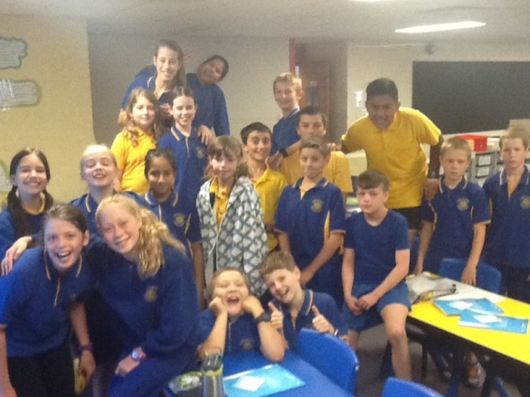

***Luminaires (6BM)***

Brenton Mace – Year 6 Teacher

[brenton.mace@ed.act.edu.au](mailto:brenton.mace@ed.act.edu.au)

**FRONT OFFICE**

Notes home from 11 February 2015

* Christian Education In School’s (CEIS) Permission form

**Excursion/Activities Acquittals Term 4, 2014**

**Hall’s Museum – 21 October**

Expenses: $328.36; Payment Received: $345.00

Difference: $16.64

**Camp Cooba – 05 – 07 November**

Expenses: $8,945.45; Payment Received: $8,700.00

Difference: ($245.45)

**NEWS FROM THE LAVA LAMP (THE LIBRARY)**

Welcome to 2015! It is going to be a great year in the Lava Lamp this year with all students having library lessons and borrowing time each week.

**SOMETHING NEW!**

In order to reignite the Giralang Primary library passion, we are trialling using Twitter as a way of connecting what we read to the outside world, there are so many fantastic authors and illustrators using Twitter, we are excited to Tweet with them! Please see the attached Twitter in the Library letter for more information. As this is a trial, we would appreciate any feedback that you have on what we are doing, either in person or via email or a letter to Miss Love or Mrs Hepburn. If you are on Twitter, you can find us using this Twitter handle @LibraryGPS

**USING TWITTER IN OUR LIBRARY:**

* We are **NOT** asking students to create a Twitter account, they will use one which is owned by the GPS Library
* Students will **NOT** have access to Twitter on the student computer network
* We will **NOT** use photos of students
* We will **NOT** use full names of students
* Students **MUST** have all Tweets approved by Mrs Hepburn **BEFORE** they are Tweeted.
* All Tweets **MUST** be about our library learning program, or books we love.

**JUST A REMINDER!**

We have a great range of books in our library collection, and we really want to make sure that they are cared for at all times. With this in mind, children **MUST** use a material library bag in order to borrow books. Please don’t go buying new library bags, you can repurpose a ‘green’ shopping bag, add handles to an old pillow case, or use the blue bag from the stationary packs.

Students are encouraged to choose and borrow books which they are interested in when using the library as the library is about inspiring reading for pleasure. This may mean that they bring home books that are more difficult than their home readers. If you are concerned about the books that your child is bring home from the library, please pop in for a chat!

**HOW MANY BOOKS CAN I BORROW?**

Preschool – 1 book Year 1 – 2 books Year 3 – 4 books Year 5 – 4 books

Kindergarten – 2 books Year 2 – 2 books Year 4 – 4 books Year 6 – 4 books

**WHEN IS MY LIBRARY DAY?**

Each class is timetabled for a library session, which will include borrowing time. Please ensure that your child has their library bag on their library day.

***Monday Tuesday Wednesday Thursday Friday***

Preschool Photons (2B) Lasers (5B) Rainbows (1K) Sunrises (3L)

Sparks (4/5W) Fireflies (4G) Supernovas (1F)

Auroras (2M) Stars (KD) Luminaires (6B)

Twilights (KN)

Preschool

If you have any questions, or would like to offer to help out in the library, please drop past and have a chat, or drop me an email.

Dot Hepburn

[Dorothy.hepburn@ed.act.edu.au](mailto:Dorothy.hepburn@ed.act.edu.au)

**Mainly music** is a fun, interactive music session for young children.  The children and their parents/caregivers join together for a fun, thirty-minute music session, and then afterwards enjoy refreshments in a relaxed setting. **Mainly music** is an activity you and your children (0-5 yrs) can participate in.

Our **mainly music** group meets on **Thursday** mornings from **10.00am to 11.00am** at St Simon’s Anglican Church, Georgina Cres, Kaleen. The cost is $5 per family per week. The sessions will commence on **12 February.**

To reserve a place please go to the church website: [www.stsimons.org.au](http://www.stsimons.org.au), find the **Mainly Music** section, and fill in the on-line form or contact 6241 2034 for further information.

C:\Program Files\Microsoft Office\MEDIA\CAGCAT10\j0158007.wmf

**SCOUTS =Adventure + Life Skills**

Scouting is for boys and girls aged 6-25. Scouts participate in programs that encourage them to grow through adventure by experiencing new challenges, making new friends, building confidence, taking responsibility for themselves, and being provided with opportunities to explore their own abilities and interests. Come and try Scouts today and take advantage of our 3 week FREE trial.

Visit **scoutsact.com.au** to find your closest Scout Group or call **1800 SCOUTS**



